Weekly Activity 5
Complex Acoustic Events
For the following activities, you will need two, free software programs. The first is Audacity (http://www.audacityteam.org/) and the second is Praat (http://www.fon.hum.uva.nl/praat/). Please visit each of these websites and download the programs. Those of you with Mac computers will have to play with your security settings because these do not come from the Apple Store. Those of you with Windows PCs won’t have an issue.

You will also need a screen capture tool (Jing works well for both Macs and PCs: https://www.techsmith.com/jing.html and for tutorials for Jing, go to: https://www.techsmith.com/tutorial-jing.html). For PC users, you can choose Snip (this is what I use: https://www.microsoft.com/en-us/garage/project-details.aspx?project=snip).

You may want to edit screen captures (like cropping, etc.). GIMP is a free tool to edit images and works on both PCs and Macs (https://www.gimp.org/).

Purpose: The purpose of the activity is for you to create and describe both simple and complex acoustic events.

Part 1: Simple Acoustic Events
The most simple acoustic event is due to sinusoidal motion. That means that an object creating a disturbance in air is vibrating at one, single frequency, creating what is known as a “pure” tone. An example of this would be a tuning fork: https://youtu.be/vNuDxc9tZMk. Because a pure tone is only made up of one frequency, the waveform is very simple and easy to make measurements in time and spatial domains. For example,

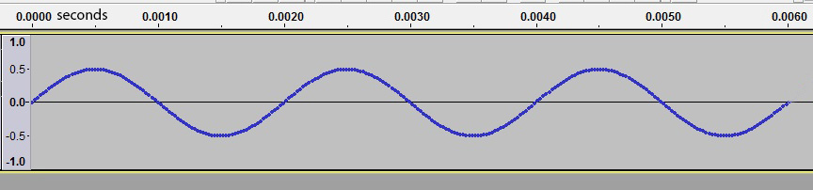

The waveform above was created from a pure tone. Based on what we see in the picture, the wave repeats itself in the same amount of time each time it repeats. Therefore, it is periodic. We can determine the frequency of the wave simply by looking at the x-axis (time domain). We see that one full cycle of vibration occurs from the 0.00s time to the 0.002s (2ms) time. That means that the period is 2ms (or 0.002 seconds). We know that T=1/f and f=1/T. So, f = 1/0.002s = 500Hz. We also know that for the wavelength, λ=c/f, where c= 33,600cm/s. So, λ = 33,600cm/s / 500cps (or Hz). So 67.2 cm is the wavelength (λ=67.2cm).

This same simple acoustic event can be visualized by looking at the frequency components that make up the signal. Since this is a pure tone, there should only be one, single frequency that makes it up. And, indeed, we see that in the frequency spectrum below.
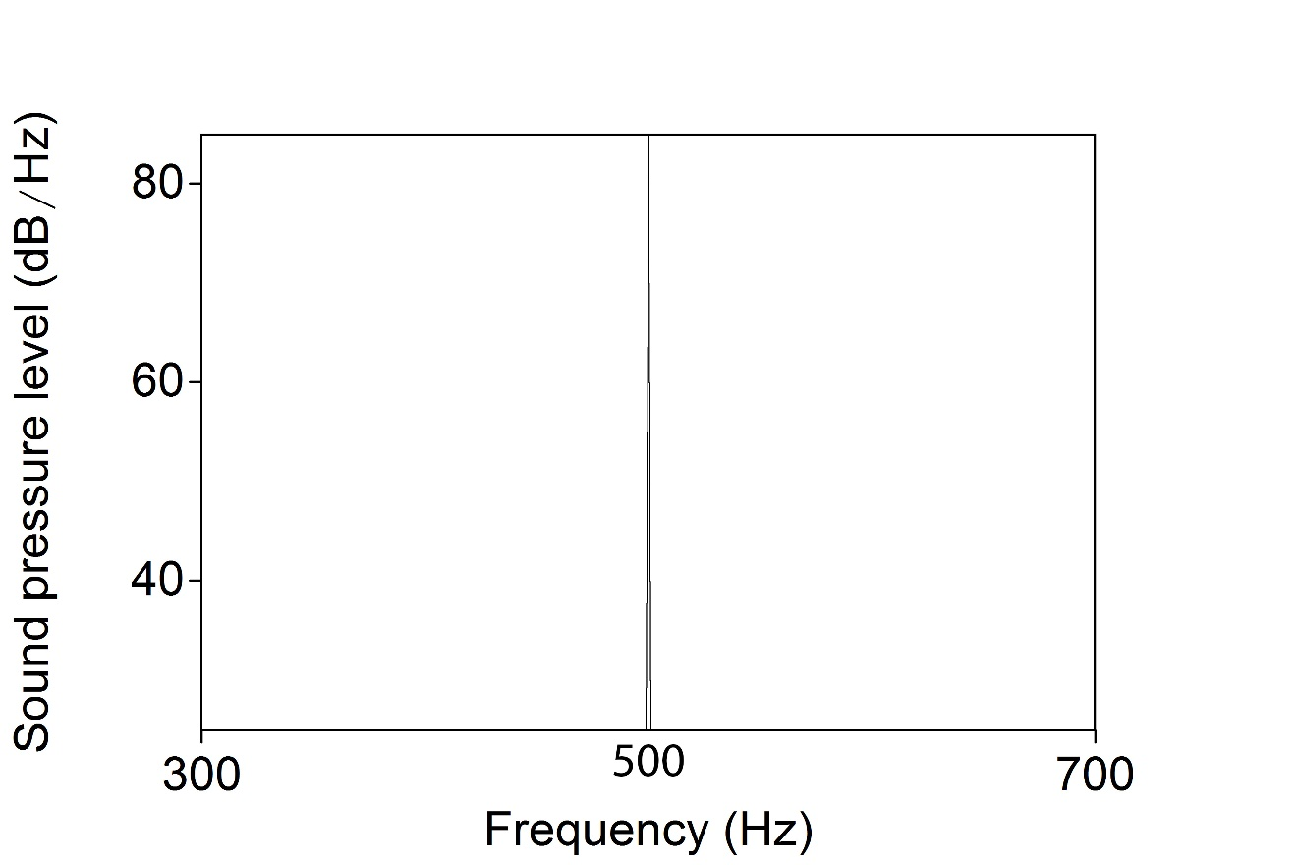

There is only one line going upward and it is at the 500Hz mark on the spectrum’s x-axis. Relatively simple to see.

Part 2: Complex Acoustic Events
Unlike simple acoustic events (i.e., pure tones), complex acoustic events are made up of two or more frequencies. Complex acoustic events may be “split” up in the frequencies that make them up (their component frequencies) through a complex mathematical process called Fourier Analysis: https://youtu.be/r18Gi8lSkfM. As the mathematics of Fourier Analysis are beyond the scope of this course (and my personal abilities!), just knowing that complex acoustic events are separated into their component frequencies through Fourier Analysis is sufficient. Taking a different approach, we can create a complex acoustic event by adding sinusoids together.

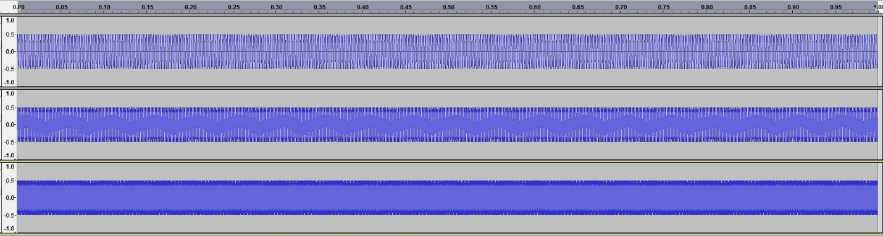
Above, you see three different pure tones, one on top of the other. The top one is a 500Hz tone, the second a 1000Hz tone and the third (bottom) is a 1500Hz tone. That means there are 1500 cycles per second which is why it looks like a solid purple bar. The time domain (x-axis) is one second. To see the waveforms a little closer, we have to zoom in and we see this:

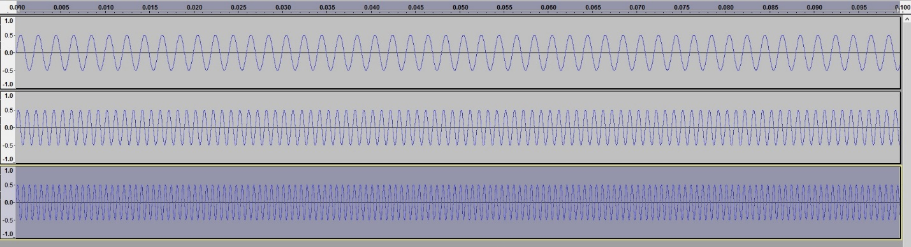

Notice that I am looking at the 0-5ms range between the first two numbers on the x-axis. The whole range here is from 0-10ms (0.01s). If I add these three pure tones together, I get the following complex waveform:

Notice that the waveform looks very different. All three of the pure tones were combined and this is the result. Even though the shape of the waveform is different, the basic frequency of its repetition does not change (it is the lowest of the three frequencies or, in this case, 500Hz). The cycle repeats in the same amount of time, every time. So this is a complex periodic waveform. Complex because it is made up of more than one frequency and periodic because it repeats in the same amount of time each cycle.

If we only had the waveform and wanted to break it down into its component frequencies (via Fourier Analysis), we would end up with a frequency spectrum (a graph that shows all the frequencies that make up a complex acoustic event). Using software, I took the complex, period sound file created by combining the three pure tones above, and created a frequency spectrum. Indeed, we see that the complex sound was made up of three frequencies: 500Hz, 1000Hz, and 1500Hz.

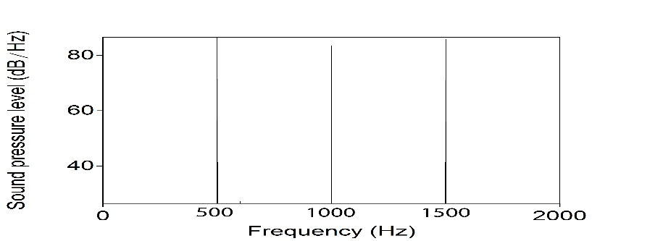

Part 3: Relationships of component frequencies
The component frequencies of a complex acoustic event may be related to one another (or not). How they are related shapes the type of complex acoustic event. For example, if all the component frequencies of a complex acoustic event are whole number multiples of the fundamental frequency (the lowest frequency in the event), we can say the frequencies are harmonically related. The healthy human voice is characterized by component frequencies that are related to one another as whole number multiples of the fundamental. For example, if the fundamental frequency of a complex acoustic event for which the component frequencies are harmonically related is 150Hz, the next component frequency would have to be 300Hz (2x150Hz), and the next 450Hz (3x150Hz) and so on. That is, the frequency components that make up complex period acoustic events are harmonically related (whole number multiples of the fundamental) and are called harmonics. The first harmonic is the fundamental frequency (1x150Hz in our example) and the second harmonic is 2x the fundamental frequency and the third harmonic is 3 x the fundamental frequency. This makes for a sound that is rich with harmonics. Again, this is for periodic complex sounds only.

We can also have complex aperiodic acoustic events and those are simply acoustic events in which the component frequencies are NOT related to one another. For example, the following waveform depicts “white noise”. White noise is a random collection of frequencies put together (it sounds like a TV station that is not tuned in).

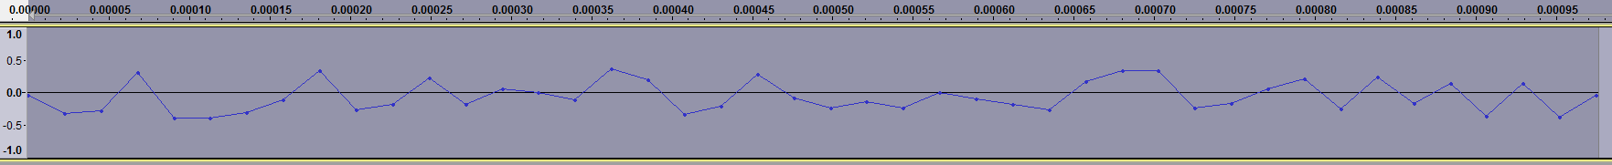

Notice that there is no discernable pattern that repeats across the waveform. Since there is no regular repetition, this is called an aperiodic sound. We can still break aperiodic sounds up into their component frequencies… but they will not be related like period sounds were.

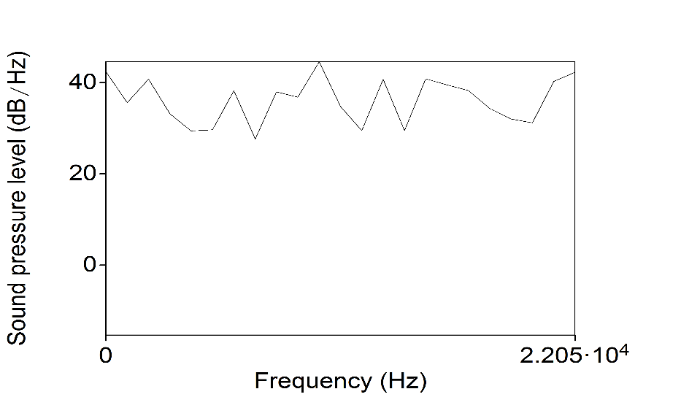

Notice there are lots of frequencies that make up the sound and they are really random (not related at all).

Extra Part: Triangular Waves
There is a special type of complex acoustic wave that it generated by a computer. It is called a triangular wave and it is made up of component frequencies that are related, but not harmonically related. Instead of being whole number multiples of the fundamental frequency, they are odd integer multiples of the fundamental. So, if the fundamental frequency of a triangular wave is 150Hz, the next component frequency is 450Hz (3x150Hz) and the next is 750Hz (5x150Hz) and so on. These are used in a lot of speech science literature as a calibration tone for calibrating recording systems.

For your weekly activity, copy and paste the text found below into a new file. That will be what you upload (don’t upload this whole file, only your work).

Assignment

1. Using Audacity and Praat (and a screen capture program as well as an image editing program), create a pure tone of any frequency you choose. Paste a copy of the waveform for the form below. Then, analyze the tone with Praat and create a frequency spectrum. Past the frequency spectrum below. Be sure to state what the frequency of your tone was and make sure to label your spectrum accordingly. Here is a sample video of how to accomplish this with Audacity and Praat (and the other software I use- yours may be different): https://youtu.be/4S19iylQm-c

2. Using Audacity and Praat (and other required software), create a complex PERIODIC sound file made up of 8 frequencies (they must share the correct relationship to one another to make the sound periodic!). Provide the component frequencies you chose and show the final waveform by pasting it below. Then, create a frequency spectrum of the sound and paste it below. Be sure to label the spectrum accordingly. Here is a sample of how to create a complex sound in Audacity: https://youtu.be/DfmM0jOxdHU.

3. Do the same thing, but create an aperiodic sound, waveform and spectrum.

4. For fun, create a triangular wave using any frequencies you would like (they must be correctly related!) and provide the waveform and frequency spectrum.

